Doolittle Raid: Man’s Strength and Weakness
By Shu Luying Class 12
War is always accompanied by a series of effects. As I will say next, Doolittle Raid plays a role in the relationship between China and the United States, the relationship between China and the United States, and the future development of China.
At midday on April 18, 1942, 16 U.S. Army bombers, under the command of daredevil pilot Lt. Col. Jimmy Doolittle, thundered into the skies over Tokyo and other key Japanese industrial cities in a surprise raid designed to avenge the attack on Pearl Harbor.
At the time, the damage caused by the Doolittle strike was negligible, but as soon as the news of the air strike broke, the United States was jubilant. From the attack on Pearl Harbor to Japan’s successive occupation of south-east Asian territory and islands, the media has been reporting bad news, and this is a time when news of victory, however small, is especially needed. Doolittle later recounted in his autobiography that the raid was intended to bolster American morale and to cause the Japanese to begin doubting their leadership, at which it succeeded.
It is no exaggeration to say that the Doolittle Raid was a spiritual turning point in the Pacific war -- more spiritual than material. China’s help is essential. As a Chinese, I am very proud of my ancestors who have been brave enough to help the friendly forces. This joint action by China and the United States not only boosted the morale of the United States, but also the morale of China and even the anti-fascist alliance. Since then, it has laid a solid foundation for the establishment of diplomatic ties between China and the United States, set a precedent for friendly exchanges between China and the United States, and established China’s good image in the world to a certain extent.
But it has also, undeniably, inflicted pain on Chinese civilians who saved American troops.
A missionary with the United Church of Canada, the Reverend Bill Mitchell traveled in the region, organizing aid on behalf of the Church Committee on China Relief. Mitchell gathered statistics from local governments to provide a snapshot of the destruction. The Japanese flew 1,131 raids against Quzhou—Doolittle’s intended destination—killing 10,246 people and leaving another 27,456 destitute. They destroyed 62,146 homes, stole 7,620 head of cattle, and burned 30 percent of the crops.
I am not here to express regret for my ancestors who saved the United States, because the Japanese invasion was not their fault, they were also the victims of the war. Even the 500 Japanese who were killed or wounded in the battle, leaving behind their identities as human beings and our fellow citizens. We should reflect on the fact that war is inevitable in the face of the tide of history -- the great heroes and friendships that have sprung up in war deserve our praise, but who would want to leave their families behind and go to war? This may be one of the reasons why the Chinese nation firmly loves peace. Therefore, this raid should also be reflected by us to work together for world peace.
Human beings are undoubtedly powerful, and in times of crisis they often erupt with surprising bravery, like the heroic pilots of the Doolittle operation and the Chinese civilians who resolutely help their friends. But humans are also weak, and in war, human life is like dust. Decades ago, China showed its kindness and love for peace to the United States. Today, China still stands in the east and presents its beauty to all countries. In the future, the image of Chinese people as trustworthy and peace-loving will be deeply rooted in the hearts of people and attract more countries to establish friendly relations with them. Friendship with the United States will also promote peaceful coexistence between the two countries.
Doolittle Raid is a bridge connecting China and the United States, and an opportunity for China to show its own virtues. It is conducive to the friendship between China and the United States, to the future exchanges and development between China and the United States, as well as to people’s reflection on themselves and the reduction of wars.

The attachment：
1.1942 - Doolittle Raid Aircrews USS ENTERPRISE CV-6
Address：http://www.cv6.org/1942/doolittle/doolittle_crews.htm

- The Untold Story of the Vengeful Japanese Attack After the Doolittle Raid
“Little did the Doolittle men realize,” the Reverend Charles Meeus later wrote, “that those same little gifts which they gave their rescuers in grateful acknowledgement of their hospitality— parachutes, gloves, nickels, dimes, cigarette packages—would, a few weeks later, become the telltale evidence of their presence and lead to the torture and death of their friends!”
Those discovered to have helped the Doolittle raiders were tortured. In Nancheng, soldiers forced a group of men who had fed the airmen to eat feces before lining up ten of them for a “bullet contest” to see how many people a single bullet would pass through before it stopped. In Ihwang, Ma Eng-lin, who had welcomed injured pilot Harold Watson into his home, was wrapped in a blanket, tied to a chair and soaked in kerosene. Then soldiers forced his wife to torch him.
@SmithsonianMag on Twitter
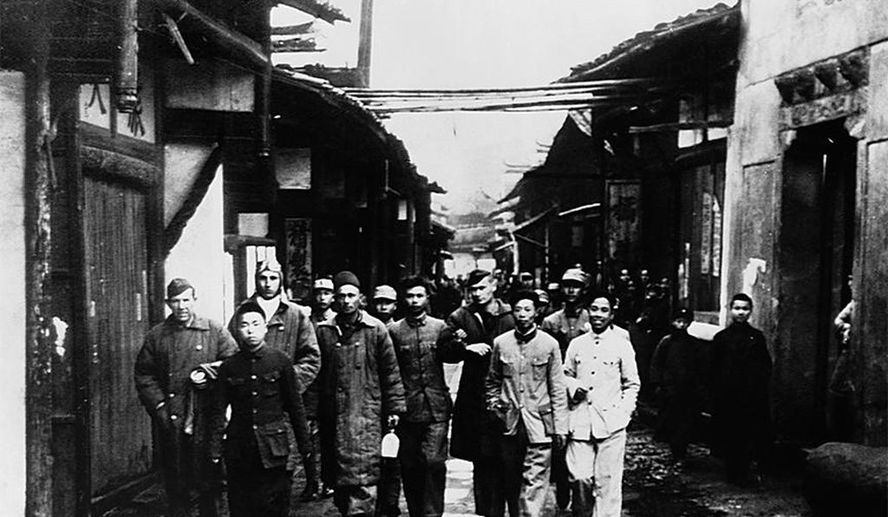
Address: https://www.smithsonianmag.com/history/untold-story-vengeful-japanese-attack-doolittle-raid-180955001/
Major General Doolittle’s fliers in China after the Doolittle Raid on Tokyo of April 18, 1942. (Corbis)
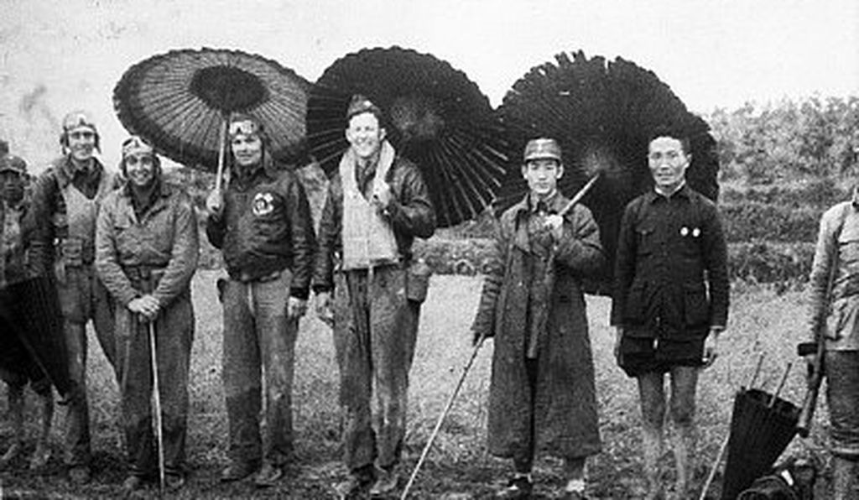

Four of the American fliers who raided Tokyo grin out from beneath Chinese umbrellas that they borrowed. (Bettmann/Corbis)

3.Doolittle Raid Wikipedia
Doolittle Raid
Part of the Pacific War of World War II
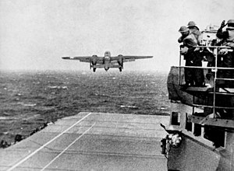
A B-25 taking off from USS Hornet (CV-8) for the raid
Date | Saturday, April 18, 1942
Location | Greater Tokyo Area, Japan
Result | - US propaganda victory; US and allies morale improved  - Minor physical damages, significant psychological effects

Belligerents
United States  China | Japan
Commanders and leaders
James H. Doolittle | Prince Naruhiko Higashikuni
Strength
16 B-25 Mitchell medium bombers  - 80 airmen (52 officers, 28 enlisted)  2 aircraft carriers  4 cruisers  8 destroyers | Unknown number of Kawasaki Ki-61 Hien fighters and anti-aircraft artillery[3]
Casualties and losses
3 dead  8 POWs (4 lived to be rescued and 4 died in captivity: 3 executed, 1 by disease)  15 B-25s  1 interned in the Soviet Union | - About 50 dead, 400 injured (including civilians)  - 5 sailors captured  - 5 patrol boats sunk  - At least 3 aircraft shot down  - One nearly converted aircraft carrier damaged

Address:
https://en.m.wikipedia.org/wiki/Doolittle_Raid

4.Doolittle and Glines 1991, pp.1-2
The Japanese people had been told they were invulnerable ... An attack on the Japanese homeland would cause confusion in the minds of the Japanese people and sow doubt about the reliability of their leaders. There was a second, and equally important, psychological reason for this attack ... Americans badly needed a morale boost.

5.Ningbo Battle Baidu
Address: https://baike.baidu.com/item/%E6%B5%99%E8%B5%A3%E4%BC%9A%E6%88%98/3689680?fromtitle=%E6%B5%99%E8%B5%A3%E6%88%98%E5%BD%B9&fromid=1052427&fr=aladdin#1

- Doolittle Raid Baidu
For the 80 volunteer raiders, who lifted off that morning from the carrier Hornet, the mission was one-way. After attacking Japan, most of the aircrews flew on to Free China ,in the vicinity of Zhejiang, Chongqing, Jiangxi, the No. 8 of York landed in the territory of the Soviet union, and the 8 missing crew members of No. 6 of Hallmark and No. 16 of Farrow were detained in the Japanese military Shanghai police headquarters.
At the time, the damage caused by the doolittle strike was said that shortly after it, all the bombed facilities were restored. The Dolittle fleet bombed eight primary and five secondary targets. In Tokyo, targets include a fuel storage warehouse, a steel plant and several power plants. In yokosuka, at least one of the bombs dropped on Lt. McElroy’s plane 13 exploded near completion on the Japanese imperial navy’s aircraft carrier longfeng, forcing it to lie in its dock until November. Six other schools and an army hospital were also bombed.
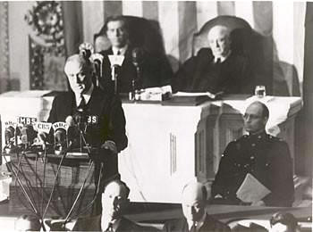
Address:
https://baike.baidu.com/item/%E7%A9%BA%E8%A2%AD%E4%B8%9C%E4%BA%AC/6874514?fromtitle=%E6%9D%9C%E7%AB%8B%E7%89%B9%E7%A9%BA%E8%A2%AD&fromid=846133&fr=aladdin#4
7.Pearl Harbor （Movie）

